**HOSTEL ROOM RESERVATION AND CANCELLATION SYSTEM**

**A PROJECT REPORT**

***Submitted by***

**REUBEN ABRAHAM GEORGE (220701223)**

***in partial fulfillment of the course***

**CS19542 – INTERNET PROGRAMMING**

***for the degree of***

**BACHELOR OF ENGINEERING**

***in***

**COMPUTER SCIENCE AND ENGINEERING**

**RAJALAKSHMI ENGINEERING COLLEGE RAJALAKSHMI NAGAR THANDALAM CHENNAI – 602 105**

**NOVEMBER 2024**

**1. Introduction**

The **Hostel Room Reservation System** is a comprehensive digital solution designed to streamline the process of managing hostel room bookings in educational institutions. The system caters to the needs of students, administrators, and hostel management by automating reservation workflows and enhancing the overall user experience. This modern approach eliminates the inefficiencies of traditional manual booking processes, offering a seamless and structured interface that is accessible anytime and from any device.

**1.1 Problem Statement**

Managing hostel accommodations manually is a time-consuming and error-prone task. Traditional systems often involve paperwork, back-and-forth communication, and delays in processing reservations. These inefficiencies can lead to mismanagement, such as double bookings, misplaced requests, and unsatisfactory user experiences. For institutions with a high influx of students, these issues can escalate, affecting operational efficiency and student satisfaction.

**1.2 Objectives**

The Hostel Room Reservation System aims to:

1. **Simplify the Booking Process**: Provide an easy-to-navigate platform for students to reserve rooms with minimal effort.
2. **Automate Data Management**: Ensure that all reservation details are securely stored and readily accessible for review and approval.
3. **Enhance User Experience**: Offer a visually appealing and user-friendly interface, accommodating the needs of tech-savvy students.
4. **Improve Efficiency**: Reduce administrative burden by automating repetitive tasks and minimizing errors.

**1.3 Scope**

This system is tailored for use in educational institutions, including colleges and universities, where hostel accommodations are provided. It supports various functionalities, such as:

* Selecting room types and amenities.
* Submitting student details for identification.
* Accessing updates on room availability, rules, and deadlines.
* Simplifying backend management for administrators.

**1.4 Key Features**

1. **Dynamic User Interface**: A responsive design compatible with desktops, tablets, and mobile devices.
2. **Comprehensive Room Selection**: Options for single, double, or four-sharing rooms with add-on amenities like air conditioning or coolers.
3. **Automated Notifications**: Alerts for reservation confirmation, deadlines, and important announcements.
4. **Customizable Design**: Can be adapted to suit the specific needs of any institution.

**1.5 Importance of the System**

The Hostel Room Reservation System significantly improves the efficiency of hostel management. By digitizing operations, the system reduces administrative workload, minimizes booking conflicts, and enhances communication between students and management. Additionally, the system offers scalability, making it suitable for institutions of varying sizes and complexities.

**2. Features Overview**

The **Hostel Room Reservation System** is designed to provide an efficient, user-centric platform for managing hostel reservations. This system combines simplicity with robust functionality, catering to the needs of both students and administrators. The key features of this system are explained in detail below:

**2.1 Interactive Home Page**

The home page serves as the central hub of the system, offering a welcoming interface with essential features:

1. **Image Carousel**:
   * A dynamic slider displays high-quality images of hostel facilities, such as rooms, recreational areas, and dining facilities.
2. **Announcements Section**:
   * Displays important updates in a scrolling marquee format, such as maintenance schedules, new room availability, and booking deadlines.
3. **Quick Navigation**:
   * Links to key pages, such as **Registration**, **Rules**, and **Student Details**, are prominently displayed for easy access.

**2.2 Room Reservation Module**

The core of the system lies in its **Room Reservation** functionality, which simplifies the booking process:

1. **Room Selection**:
   * Students can choose from room types, including Single Sharing, Twin Sharing, and Four Sharing rooms.
   * Options are provided for AC or non-AC rooms based on comfort and budget preferences.
2. **Amenities Customization**:
   * Additional options such as fans, air conditioners, and coolers can be selected to enhance the living experience.
3. **Mess Preferences**:
   * Students can select their preferred mess for dining:
     + **Mess 1**: Offers North Indian cuisine.
     + **Mess 2**: Specializes in South Indian dishes.
   * This ensures dietary preferences are accommodated.

**2.5 User-Friendly Interface**

1. **Responsive Design**:
   * Built using HTML and Bootstrap, the system adapts seamlessly to various devices, including desktops, tablets, and smartphones.
2. **Intuitive Navigation**:
   * Organized menus and clear links make navigating between pages like Home, Registration, and Rules easy for students.

**2.8 Security Features**

1. **Secure Data Handling**:
   * The system uses secure protocols.
2. **Validation and Verification**:
   * Includes mechanisms to validate form inputs and prevent duplicate or erroneous entries.

**3. System Components**

The **Hostel Room Reservation System** is built using a combination of front-end, back-end, and database technologies to deliver a seamless and efficient user experience. This section details the system's components, emphasizing their roles, technologies, and interconnectivity.

**3.1 Front-End Components**

The front end is responsible for providing an engaging and user-friendly interface that facilitates smooth interaction between users (students and administrators) and the system.

**3.1.1 HTML (Hyper-Text Markup Language)**

* Defines the structure of web pages and organizes content into meaningful sections.
* Ensures semantic clarity for elements such as forms, navigation menus, and announcements.

**3.1.2 CSS (Cascading Style Sheets)**

* Provides styling to the web pages, ensuring a visually appealing design.
* Custom CSS rules enhance the look and feel, such as fonts, colours, button styles, and hover effects.

**3.1.3 Bootstrap Framework**

* A responsive CSS framework that adapts the design for various devices (desktop, tablet, or mobile).
* Bootstrap components, such as carousels and navigation bars, simplify development while maintaining professional aesthetics.
* Example: The carousel on the **Home Page** displays images dynamically to engage users.

**3.1.4 JavaScript (Optional Enhancements)**

* Add interactivity, such as validating user input before form submission or enabling dynamic updates (e.g., announcement scrolling).
* Ensures smoother user interactions and minimizes form submission errors.

**3.2 Back-End Components**

The back-end handles the processing, logic, and storage of user data submitted through the front-end.

**3.2.1 PHP (Hypertext Preprocessor)**

* Manages server-side logic, including data processing and storage.
* Handles form submissions from the registration page (**reg.html**) and processes them in the script (**regg.php**):
  + Validate input fields to ensure mandatory details are provided (e.g., name, email, phone number).
  + Safely stores data or displays error messages for incorrect submissions.
* Generates dynamic content, such as personalized reservation confirmations.

**3.2.2 Form Handling**

* Implements POST methods for secure data submission to the server.
* Processes uploaded files (e.g., student photographs) and validates file types and sizes before storing them.

**3.3 Database (Assumed Integration with MySQL)**

While the provided files don't explicitly include database operations, a typical system would incorporate a database like MySQL for persistent storage.

**4. User Interface**

1. **Dynamic Visuals**:
   * A full-width **carousel** showcasing hostel facilities.
   * High-resolution images for a professional look and feel.
2. **Interactive Navigation**:
   * Links to critical sections like Home, Register, Rules, and Student Details.
   * Ensures quick access to desired pages.
3. **User-Friendly Forms**:
   * Collects essential details such as name, address, and phone number.
   * Offers dropdowns and checkboxes for room and mess preferences

**5. Technical Stack**

1. **Front-End:**
   * **HTML5**: For structuring web pages.
   * **CSS**: Custom styles for visual enhancement.
   * **Bootstrap**: For a responsive layout compatible with all devices.
2. **Back-End**:
   * **PHP**: Manages form submissions, data processing, and dynamic page generation.
   * **MySQL** (optional): Stores user details and room preferences.
3. **Hosting Options**:
   * Local servers: XAMPP/WAMP for testing.
   * Cloud hosting: For live deployment.

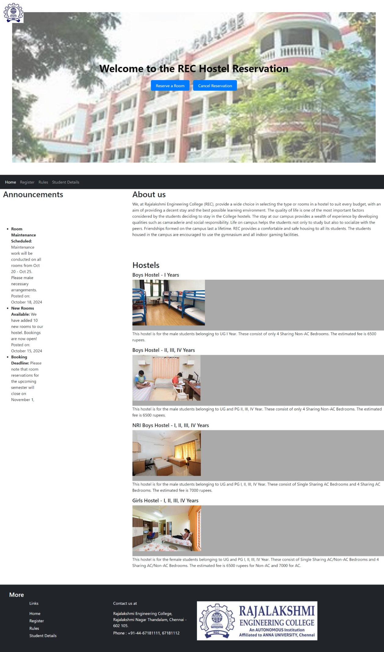

**6. Benefits of the System**

The Hostel Room Reservation System offers significant advantages:

1. **Efficiency**:
   * Automates booking, reducing manual work.
   * Minimizes errors in data collection and reservation.
2. **Accessibility**:
   * Available online 24/7 for ease of use.
   * Compatible with desktops, laptops, and mobile devices.
3. **Scalability**:
   * Can accommodate a growing number of users and reservations.
4. **Customizability**:
   * Easily adaptable to different institutions' requirements.

**10. Conclusion**

The **Hostel Room Reservation System** transforms the traditional hostel booking process into a modern, efficient digital experience. With its intuitive design and robust features, the system benefits students and administrators alike, ensuring a smooth and hassle-free reservation process. It is a significant step forward in modernizing hostel management which combines convenience, accuracy, and scalability to meet the needs of both students and institutions. By adopting this system, educational institutions can ensure an efficient, transparent, and hassle-free hostel booking experience while laying the foundation for future innovations.